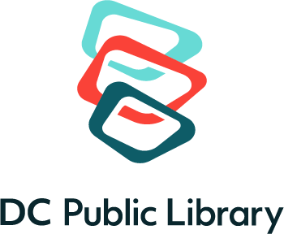
Educator Card Registration Form
 Letter on School Letterhead
 Current Paystub
 Copy of Daycare License
 Other ___________________

(Please Print) _________________________
Name: Birth Date (Month Day Year)

________________________________________________________________________
Last Name First Name Middle Initial
School:
- Preschool □ Elementary □ Secondary □ Home school □ Summer
- Other______________________________________________________________
________________________________________________________________________
School Name Principal’s name

________________________________________________________________________
Street Address

________________________________________________________________________
City State Zip Code Ward

Telephone numbers: Work: __________________ Home: _____________________
To place a reserve, renew book, or receive email announcement please provide email.
Email address: __________________________@_______________________________
Home:
________________________________________________________________________
Street Address

________________________________________________________________________
City State Zip Code Ward/County

Statement of Educator Card Privileges and Responsibilities
- This card enables the registrant to borrow books and audiobooks, not DVDS. It is valid at any D.C. Public Library.
- Registrant is responsible for all library materials checked out using this card.
- All materials should be returned promptly. Failure to return materials or replace damaged or lost items can result in suspension of borrowing privileges. The library may resort to legal action to retrieve overdue materials or obtain payment for lost or damaged materials.
- Lost cards and changes in school, home, or email address, should be reported promptly.
- There is a replacement charge for a lost card.
- The card is the property of the D.C. Public Library.
- DCPL is not responsible for lost, stolen, or abandoned cards.

________________________________ _______________________________
Signature Date

